**Detecting Malaria with Deep Learning**

**Introduction**

Malaria is a deadly, infectious mosquito-borne disease caused by Plasmodium parasites. The deadly disease has reached epidemic, even endemic proportions in different parts of the world — killing around 400,000 people annually.These deadly parasites can live in your body for over a year without any problems! Thus, a delay in the right treatment can lead to complications and even death. Hence early and effective testing and detection of malaria can save lives.

**Solution:**

The most widely used method (so far) is examining thin blood smears under a microscope, and visually searching for infected cells. The patients’ blood is smeared on a glass slide and stained with contrasting agents to identify infected parasites in their red blood cells. Then, a pathologist manually counts the number of parasitic red blood cells — sometimes up to 5,000 cells

Convolutional neural networks have the ability to automatically extract features and learn filters. In previous machine learning solutions, features had to be manually programmed in — for example, size, color, the morphology of the cells. Utilizing convolutional neural networks (CNN) will greatly speed up prediction time while mirroring (or even exceeding) the accuracy of clinicians. We’re going to be using Keras, with a Tensorflow backend.

**Technical Architecture:**

. 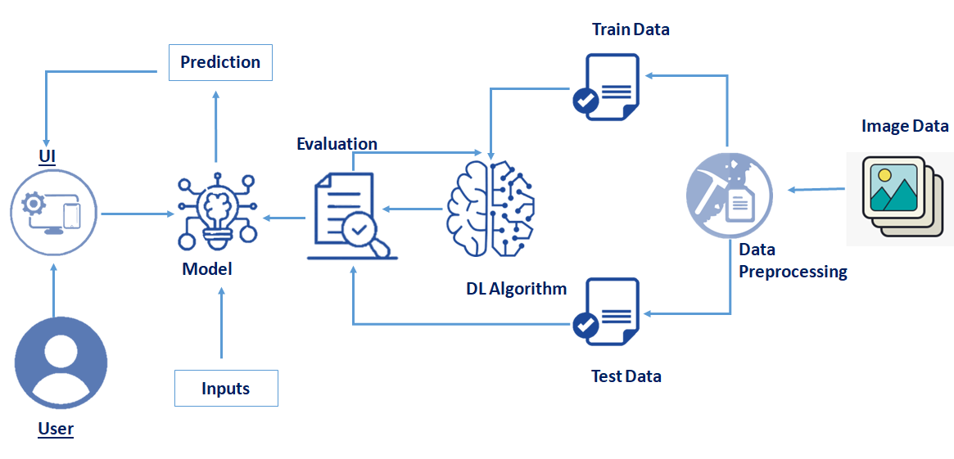

**Pre requisites:**

**To complete this project, you must require following software’s , concepts and packages**

* **Anaconda navigator:**
  + Refer to the link below to download anaconda navigator
  + **Link : https://www.youtube.com/watch?v=5mDYijMfSzs**
* **Python packages:**
  + open anaconda prompt as administrator
  + Type “pip install [tensorflow](https://www.tensorflow.org/install/pip)” (make sure you are working on [python](https://www.python.org/ftp/python/3.8.6/python-3.8.6rc1-amd64.exe) 64 bit)
  + Type “pip install flask”.

or

* + Open anaconda prompt as administrator
  + Type “pip install -r requirements.txt” (make sure you are working on [python](https://www.python.org/ftp/python/3.8.6/python-3.8.6rc1-amd64.exe) 64 bit)
* **Deep Learning Concepts** 
  + **CNN:** <https://towardsdatascience.com/basics-of-the-classic-cnn-a3dce1225add>
  + **Flask Basics** : <https://www.youtube.com/watch?v=lj4I_CvBnt0>

**Project Objectives:**

By the end of this project you will:

* know fundamental concepts and techniques of Convolutional Neural Network.
* gain a broad understanding of image data.
* Knowhow to pre-process/clean the data using different data preprocessing techniques.
* know how to build a web application using Flask framework.

**Project Flow:**

* User interacts with the UI (User Interface) to upload the image as input
* Uploaded image is analyzed by the model which is integrated
* Once model analyses the uploaded image, the prediction is showcased on the UI

To accomplish this, we have to complete all the activities and tasks listed below

* Data Collection.
  + Collect the dataset or Create the dataset
* Data Preprocessing.
* Import the ImageDataGenerator library
* Configure ImageDataGenerator class
* Apply ImageDataGenerator functionality to Trainset and Testset
* Model Building
  + Import the model building Libraries
  + Initializing the model
  + Adding Input Layer
  + Adding Hidden Layer
  + Adding Output Layer
  + Configure the Learning Process
  + Training the model
  + Save the Model
  + Test the Model
* Application Building
  + Create an HTML file
  + Build Python Code

**Project Structure:**

Create a Project folder which contains files as shown below

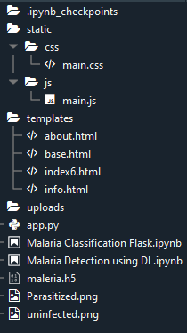

* We are building a Flask Application which needs HTML pages stored in the templates folder and a python script app.py for serverside scripting
* we need the model which is saved and the saved model in this content is maleria.h5
* The static folder will contain js and css files.
* Whenever we upload a image to predict, that images is saved in uploads folder.

**Activities:**

**Milestone 1: Data Collection**

ML depends heavily on data, without data, it is impossible for a machine to learn. It is the most crucial aspect that makes algorithm training possible. In Machine Learning projects, we need a training data set. It is the actual data set used to train the model for performing various actions.

**Activity 1** : **Download The dataset**

You can collect datasets from different open sources like kaggle.com, data.gov, UCI machine learning repository etc.

The dataset used for this project was obtained from Kaggle . Please refer to the link given below to download the data set and to know about the dataset

**Link:** <https://www.kaggle.com/iarunava/cell-images-for-detecting-malaria>

The dataset contains two classes: 1.Infected (Parasitized)

2. Uninfected

**Milestone 2: Image Preprocessing**

* + Link : <https://thesmartbridge.com/documents/spsaimldocs/CNNprep.pdf>

**Activity 1:** **Import the ImageDataGenerator library**

Image data augmentation is a technique that can be used to artificially expand the size of a training dataset by creating modified versions of images in the dataset.

The Keras deep learning neural network library provides the capability to fit models using image data augmentation via the ImageDataGenerator class.

Let us import the ImageDataGenerator class from keras

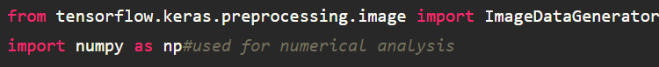

**Activity 2**: **Configure ImageDataGenerator class**

ImageDataGenerator class is instantiated and the configuration for the types of data augmentation

There are five main types of data augmentation techniques for image data; specifically:

Image shifts via the width_shift_range and height_shift_range arguments.

Image flips via the horizontal_flip and vertical_flip arguments.

Image rotations via the rotation_range argument

Image brightness via the brightness_range argument.

Image zoom via the zoom_range argument.

An instance of the ImageDataGenerator class can be constructed.



validation_split: Optional float between 0 and 1, fraction of data to reserve for validation.

**Activity 3** **:Apply ImageDataGenerator functionality to Trainset and Testset**

Let us apply ImageDataGenerator functionality to Trainset and Testset by using the following code

For Trainingset using flow_from_directory function.

This function will return batches of images from the subdirectories Infected and uninfected, together with labels 0 and 1 (0 corresponding to Infected and 1 corresponding to uninfected).

Arguments:

* directory: Directory where the data is located. If labels is "inferred", it should contain subdirectories, each containing images for a class. Otherwise, the directory structure is ignored.
* batch_size: Size of the batches of data. Default: 32.
* target_size: Size to resize images to after they are read from disk.
* class_mode:

- ‘int': means that the labels are encoded as integers (e.g. for sparse_categorical_crossentropy loss).

- 'categorical' means that the labels are encoded as a categorical vector (e.g. for categorical_crossentropy loss).

- 'binary' means that the labels (there can be only 2) are encoded as float32 scalars with values 0 or 1 (e.g. for binary_crossentropy).

- None (no labels).

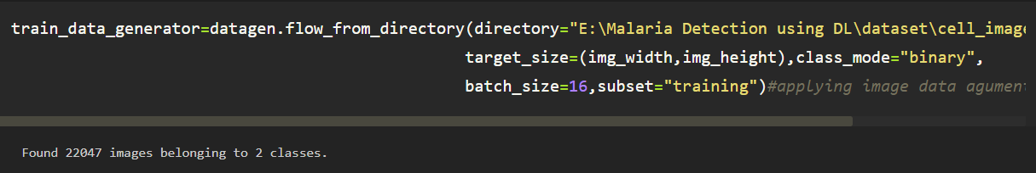

We can see that there are 22047 images belonging to 2 classes (Infected and uninfected)

For Testset

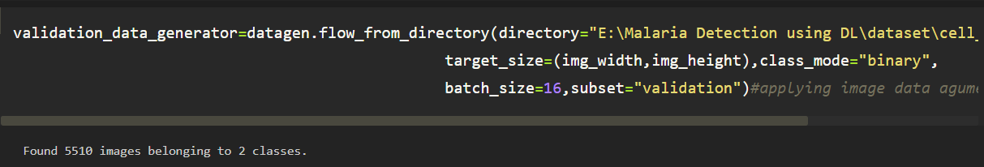

We can see that there are 5510 images belonging to 2 classes (Infected and uninfected)

**Milestone 3: Model Building**

* + Link: <https://thesmartbridge.com/documents/spsaimldocs/CNNflow.pdf>

**Activity 1 : Importing the Model Building Libraries**

Importing the necessary libraries

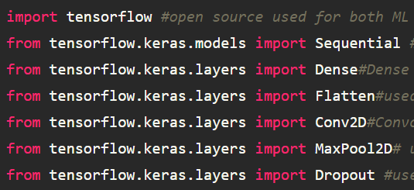

**Activity 2 : Initializing the model**

Sequential model is a linear stack of layers.You can create a Sequential model by passing a list of layer instances to the constructor: from keras. models import Sequential from keras as follows.

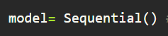

**Activity 3 : Adding CNN Layers**

* For information regarding CNN Layers reer to the link

Link: <https://victorzhou.com/blog/intro-to-cnns-part-1/>

* We are adding a convolution layer with activation function as “relu” and

with a small filter size (3,3) and number of filters (16) followed by a max pooling layer.

* Maxpool layer is used to downsample the input.
* Dropout layer is used to deactivate the neurons randomly.Dropout(0.2) indicates that 20 % of the neurons are deactivated.
* Flatten layer flattens the input. Does not affect the batch size.

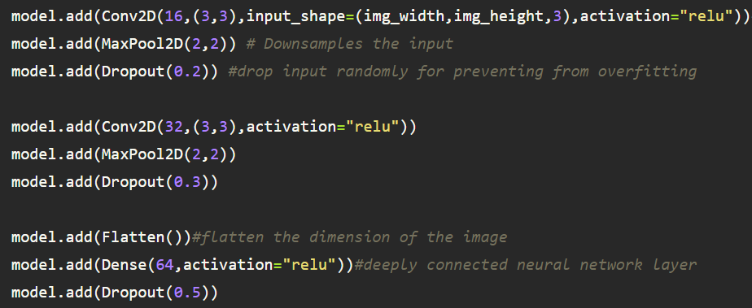

**Activity 5: Adding Dense Layers**

Dense layer is deeply connected neural network layer. It is most common and frequently used layer.

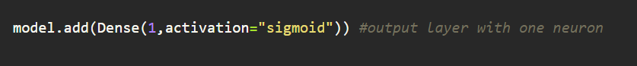

Understanding the model is very important phase to properly use it for training and prediction purposes. Keras provides a simple method, summary to get the full information about the model and its layers.

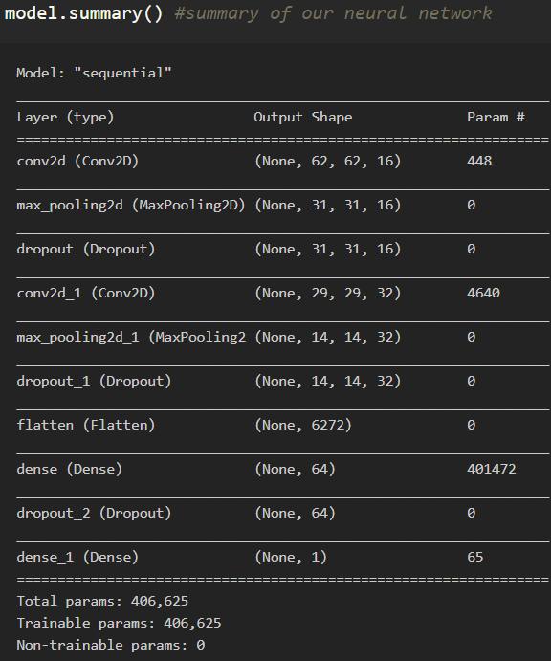

**Activity 6 : Configure The Learning Process**

* The compilation is the final step in creating a model. Once the compilation is done, we can move on to training phase. Loss function is used to find error or deviation in the learning process. Keras requires loss function during model compilation process.
* Optimization is an important process which optimize the input weights by comparing the prediction and the loss function. Here we are using adam optimizer
* Metrics is used to evaluate the performance of your model. It is similar to loss function, but not used in training process



**Activity 7: Train The model**

Now ,let us train our model with our image dataset.

**fit_generator** functions used to train a deep learning neural network

**Arguments:**

* steps_per_epoch : it specifies the total number of steps taken from the generator as soon as one epoch is finished and next epoch has started. We can calculate the value of steps_per_epoch as the total number of samples in your dataset divided by the batch size.
* Epochs : an integer and number of epochs we want to train our model for.
* validation_data can be either:

- an inputs and targets list

- a generator

- an inputs, targets, and sample_weights list which can be used to evaluate

the loss and metrics for any model after any epoch has ended.

* validation_steps :only if the validation_data is a generator then only this argument

can be used. It specifies the total number of steps taken from the generator before it is

stopped at every epoch and its value is calculated as the total number of validation data points

in your dataset divided by the validation batch size.

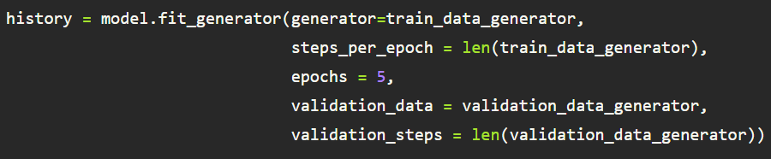

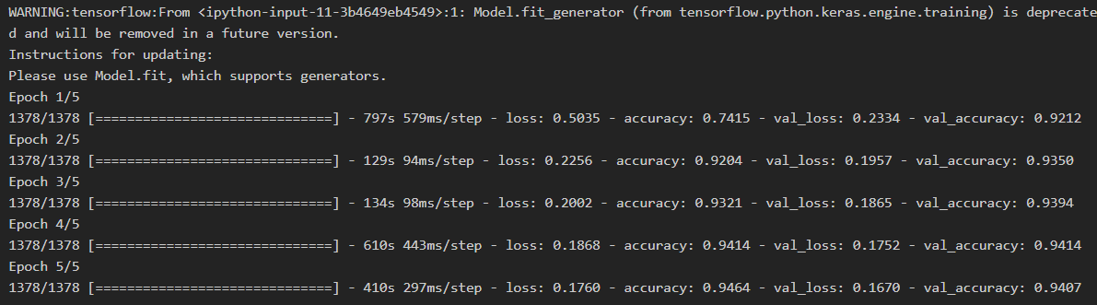

**Activity 8: Save the Model**

The model is saved with .h5 extension as follows

An H5 file is a data file saved in the Hierarchical Data Format (HDF). It contains multidimensional arrays of scientific data.

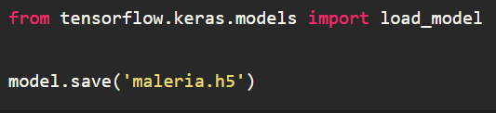

**Activity 9: Test The model**

Evaluation is a process during development of the model to check whether the model is best fit for the given problem and corresponding data.

Load the saved model using load_model

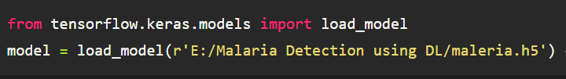

Taking an image as input and checking the results

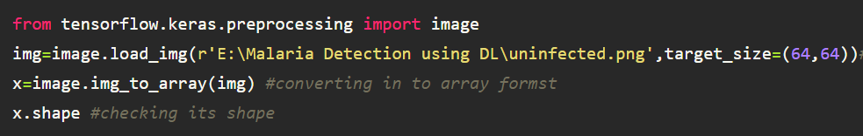

By using the model we are predicting the output for the given input image

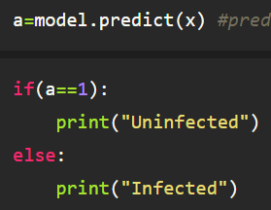

If output is 1 then Uninfected is printed else Infected.

**Milestone 4: Application Building**

Activity **1 : Create HTML Pages**

* + We use HTML to create the front end part of the web page.
  + Here, we created 4 html pages- about.html, base.html, index6.html, info.html.
  + about.html displays home page.
  + Info.html displays all important details to be known about Malaria.
  + base.html and index6.html accepts input from the user and predicts the values.

For more information regarding HTML

[**https://www.w3schools.com/html/**](https://www.w3schools.com/html/)

* + We also use JavaScript-main.js and CSS-main.css to enhance our functionality and view of HTML pages.
  + **Link :** <https://www.w3schools.com/css/>
  + [**https://www.w3schools.com/js/DEFAULT.asp**](https://www.w3schools.com/js/DEFAULT.asp)

Activity **2 :** Build python code

* + Let us build flask file’app.py’ which is a web framework written in python for server-side scripting. Let’s see step by step procedure for building the backend application.
  + App starts running when “__name__” constructor is called in main.
  + render_template is used to return html file.
  + “GET” method is used to take input from the user.
  + “POST” method is used to display the output to the user.
  + Importing Libraries

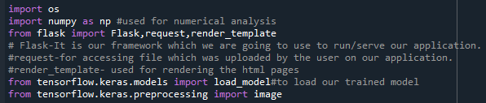

* + Routing to the html Page

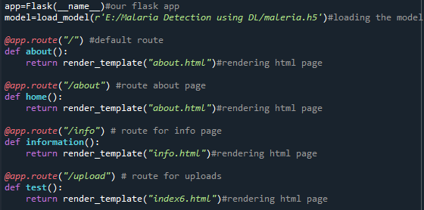

* + Showcasing prediction on UI

When the image is uploaded, it predicts whether the uploaded the image is infected or disinfected. If the image predicts value as 1, then it is displayed as “Uninfected”. If the image predicts value as 0, then it is displayed as “Infected”.

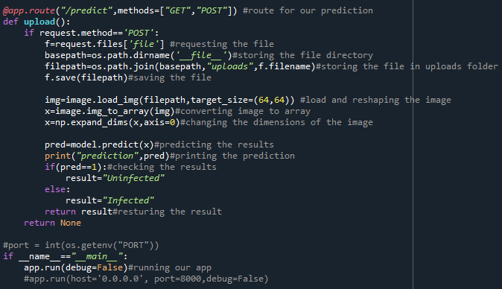

* + Run The app in local browser
  + Open anaconda prompt from the start menu
  + Navigate to the folder where your python script is.
  + Now type “python app.py” command
  + Navigate to the localhost where you can view your web page

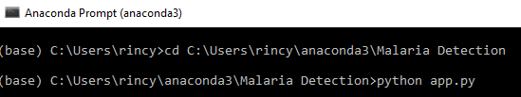

Then it will run on localhost:5000

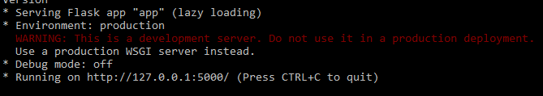

Navigate to the localhost (<http://127.0.0.1:5000/>)where you can view your web page.

Let’s see how our about.html page looks like:

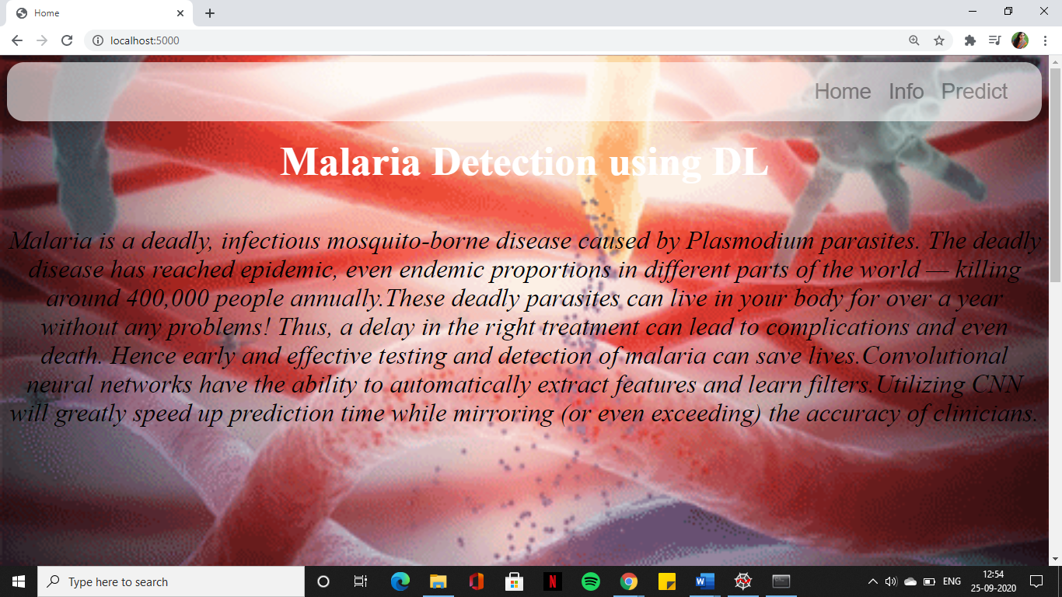

When “Info” button is clicked, localhost redirects to “info.html”

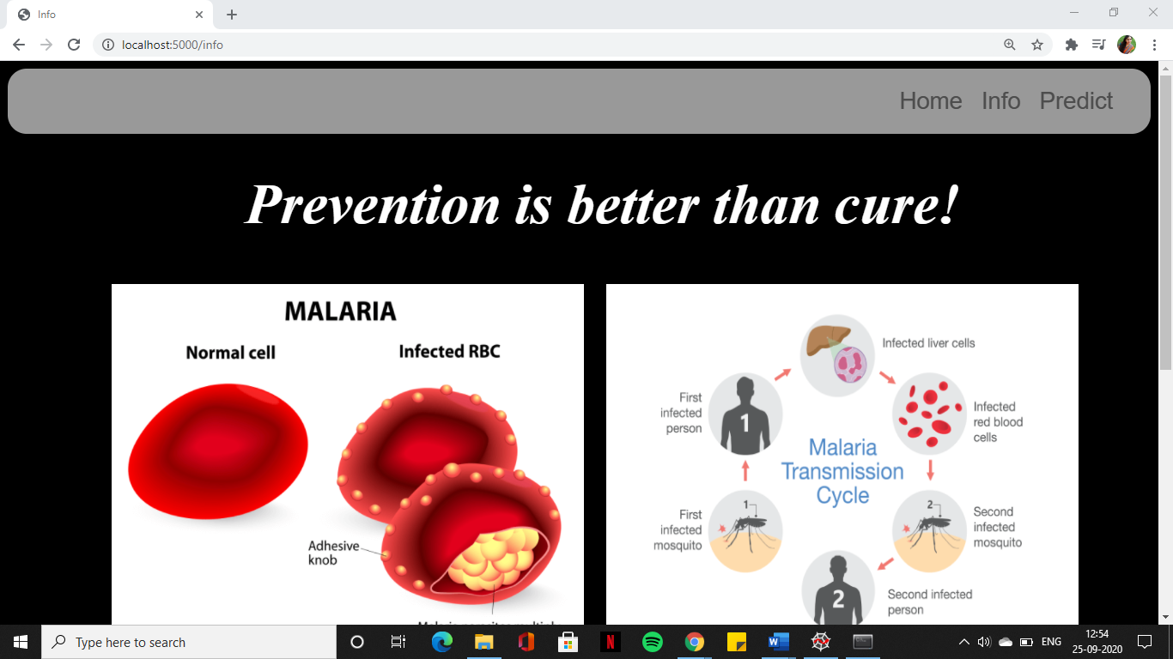

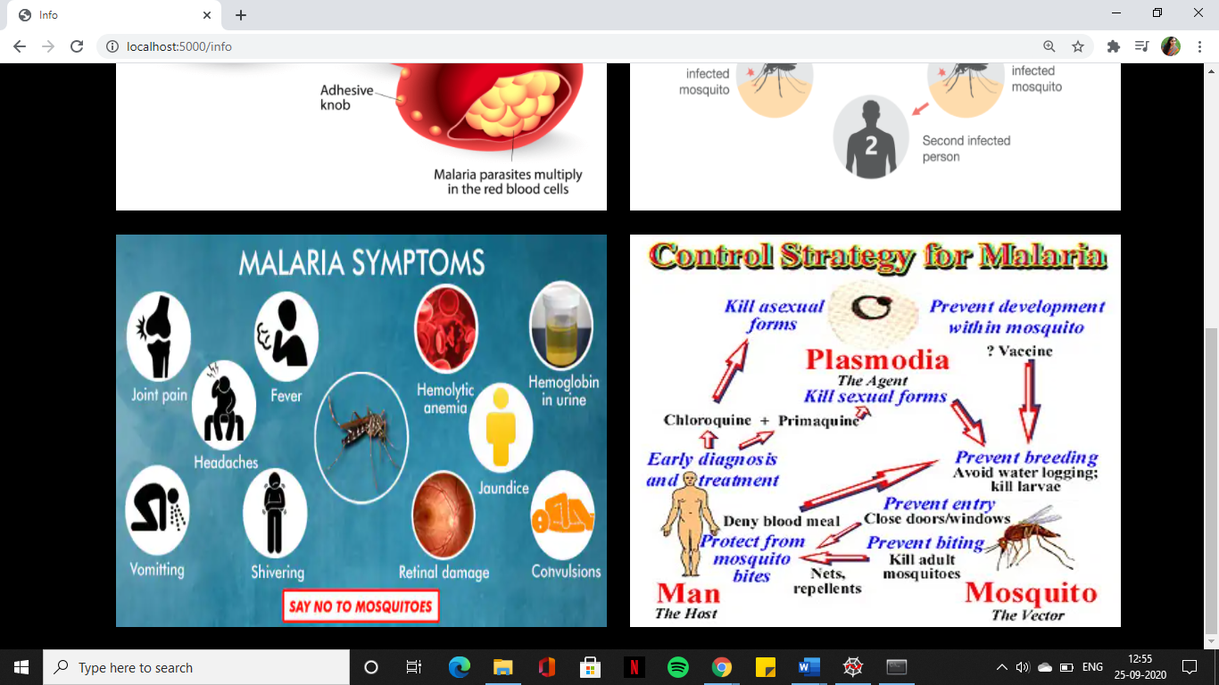

* Upload the image and click on Predict button to view the result on “base.html” page on localhost.

Prediction-1:



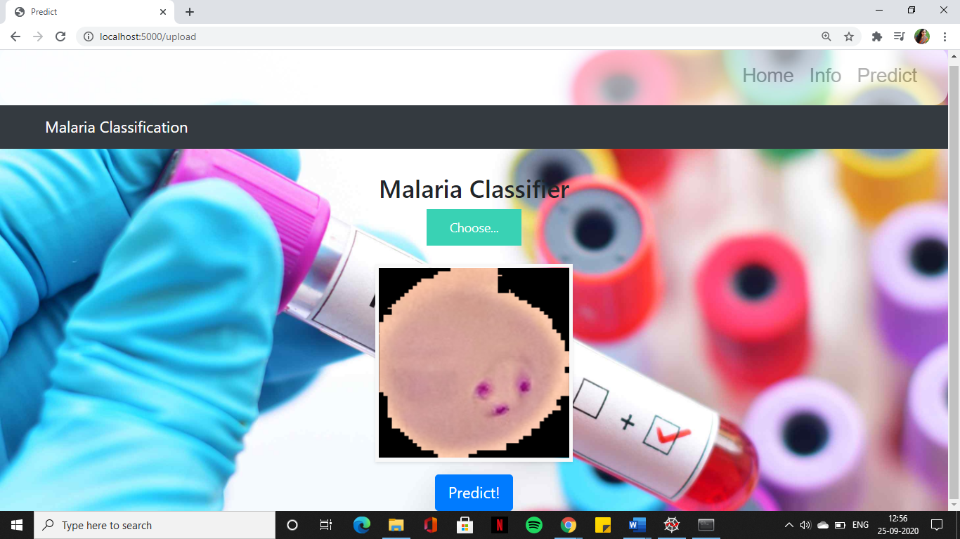

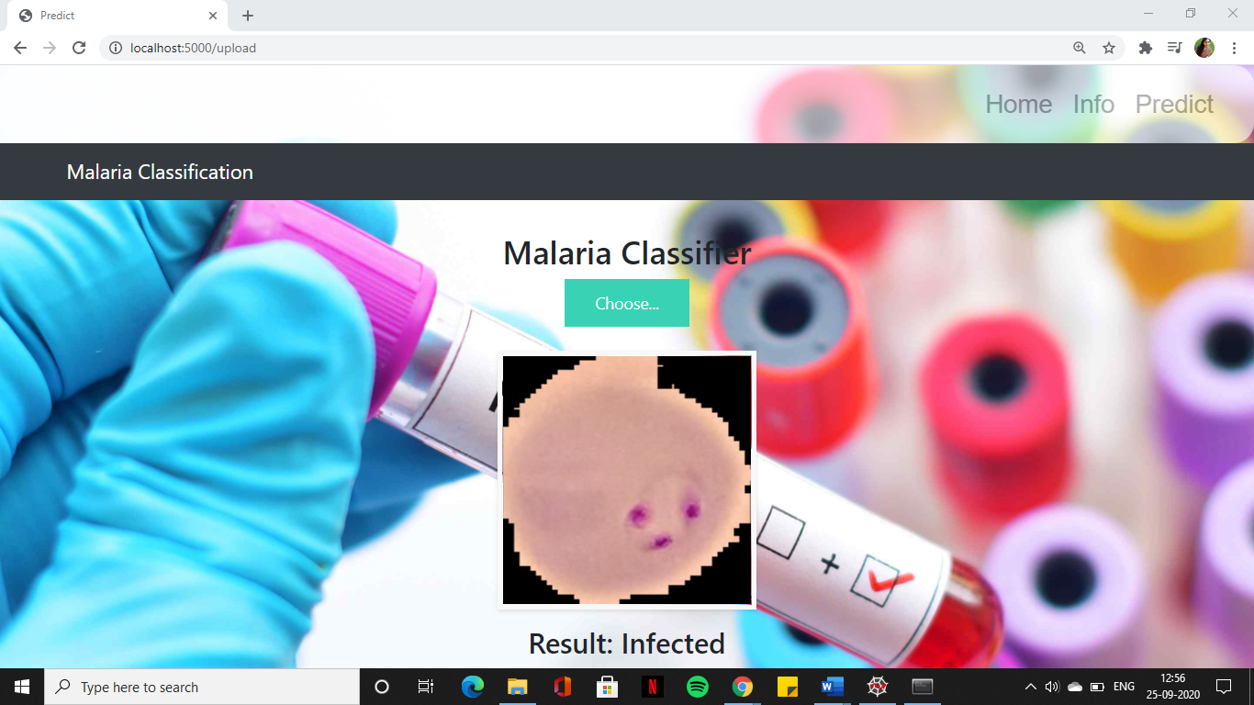

Prediction-2:



